Topic 6: Running the Application (Enterprise Execution Guide)
This document explains how to run the application in a professional, production-ready environment.
The instructions are designed for MNC-level engineering teams and follow enterprise execution standards.
Running a modern full-stack MERN application requires precise workflow sequencing, correct environment setup,
and predictable execution pipelines across development, staging, and production environments.
---
## 1. Understanding the Execution Pipeline
The project uses a dual-server architecture:
• **Frontend React server** – Handles UI rendering
• **Backend Node.js server** – Handles API, authentication, database operations
• **MongoDB database** – Stores persistent data
Running the application means these three layers must be synchronized and active simultaneously.
---
## 2. Start the Backend Server (Node.js + Express)
Navigate to the backend folder:
```
cd server
npm install
npm start
```
If running in development mode with hot reload:
```
npm run dev
```
The backend initializes:
• Middleware
• JWT authentication layer
• MongoDB connection
• Route handlers
• Error-handling pipeline
Once started, the API becomes available at:
`http://localhost:5000`
---
## 3. Start the Frontend Application (React)
Navigate to the frontend:
```
cd client
npm install
npm start
```
React dev server runs at:
`http://localhost:3000`
The frontend automatically proxies API requests to the backend for seamless development.
---
## 4. Verifying Database Connection (MongoDB)
MongoDB must be running locally or remotely (Atlas).
### For Local MongoDB:
Start the database service:
```
mongod
```
### For MongoDB Atlas:
Ensure the `.env` file contains the correct connection string:
```
MONGO_URI=your_atlas_uri
```
A stable database connection ensures:
• User authentication
• Data persistence
• Operational consistency
---
## 5. Testing Full System Synchronization
When all three components are running:
1. Open the browser: `http://localhost:3000`
2. Perform login/signup
3. Add or fetch data
4. Check backend logs for API activity
5. Check MongoDB for stored documents
If all layers communicate correctly, the system is live and fully operational.
---
## 6. High-Level Running Workflow Diagram
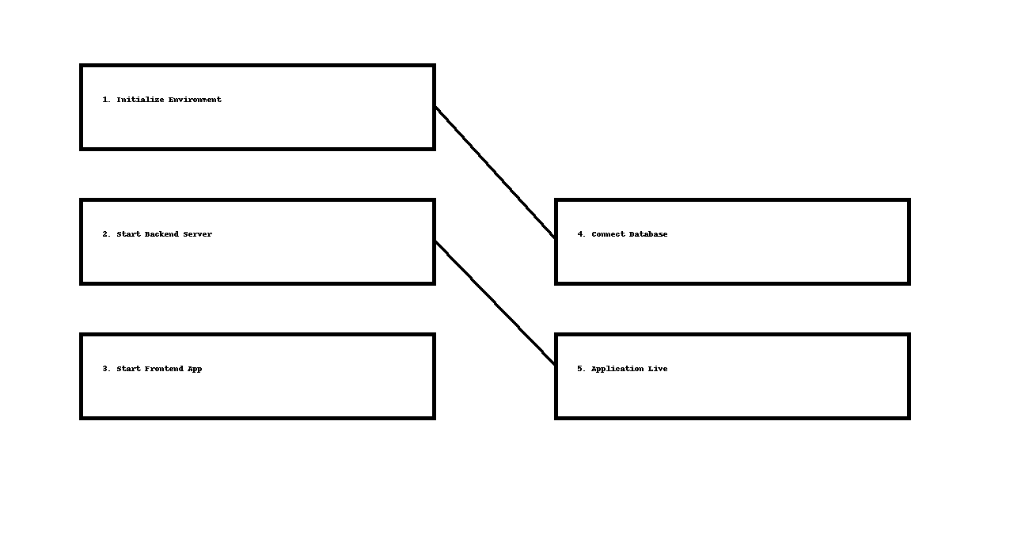
---
## 7. Running the App in Production Mode
When deploying the application to real-world environments, use optimized build commands.
### Build frontend:
```
cd client
npm run build
```
This produces a minified, enterprise-optimized distribution folder.
### Use a process manager like PM2 for backend:
```
pm2 start server.js
```
PM2 provides:
• Auto-restart on failure
• Load balancing
• Log monitoring
• Zero-downtime deployments
### Serve frontend build using nginx or cloud hosting:
Example nginx config:
```
location / {
root /var/www/frontend/build;
try_files $uri /index.html;
}
```
---
## 8. Enterprise Execution Best Practices
• Use environment-based configuration (dev, stage, prod)
• Monitor server health with tools like Grafana, Kibana, or PM2 logs
• Keep database backups automated (MongoDB Atlas snapshots)
• Enable CORS restrictions for production
• Use HTTPS for all production traffic
• Prefer Docker for consistent runtime environment
These ensure high availability, scalability, and security.
---
## 9. Conclusion
This guide provides a complete, enterprise-quality workflow for running the full-stack application.
It ensures that developers, testers, and production engineers can operate the system reliably at any scale.
The execution pipeline is optimized for real-world corporate deployments.
This concludes **Topic 6: Running the Application**.

